1. Understanding what a root folder is.
2. Page Properties
   * 1. Always save your images in a folder labeled: Image
        1. Why?

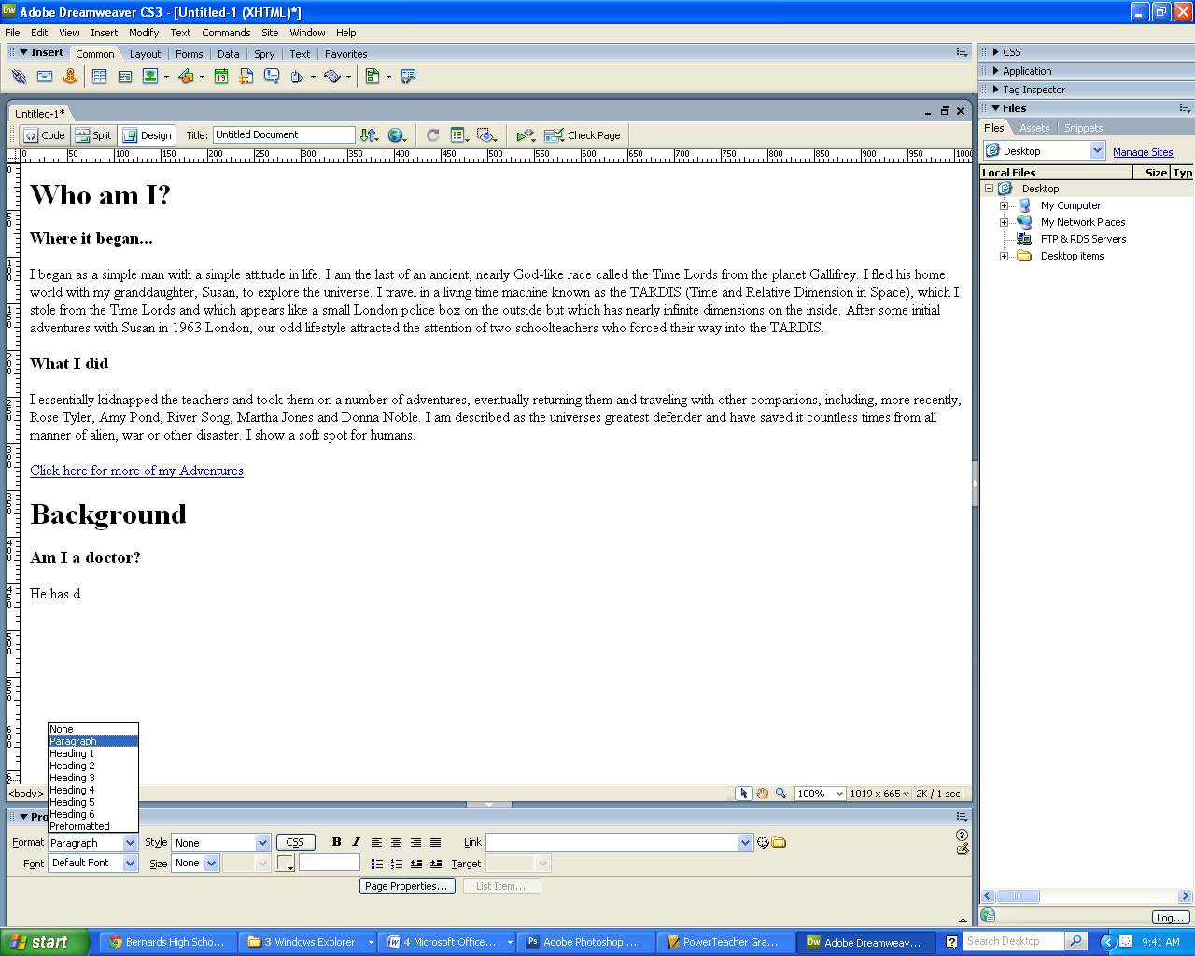

1. 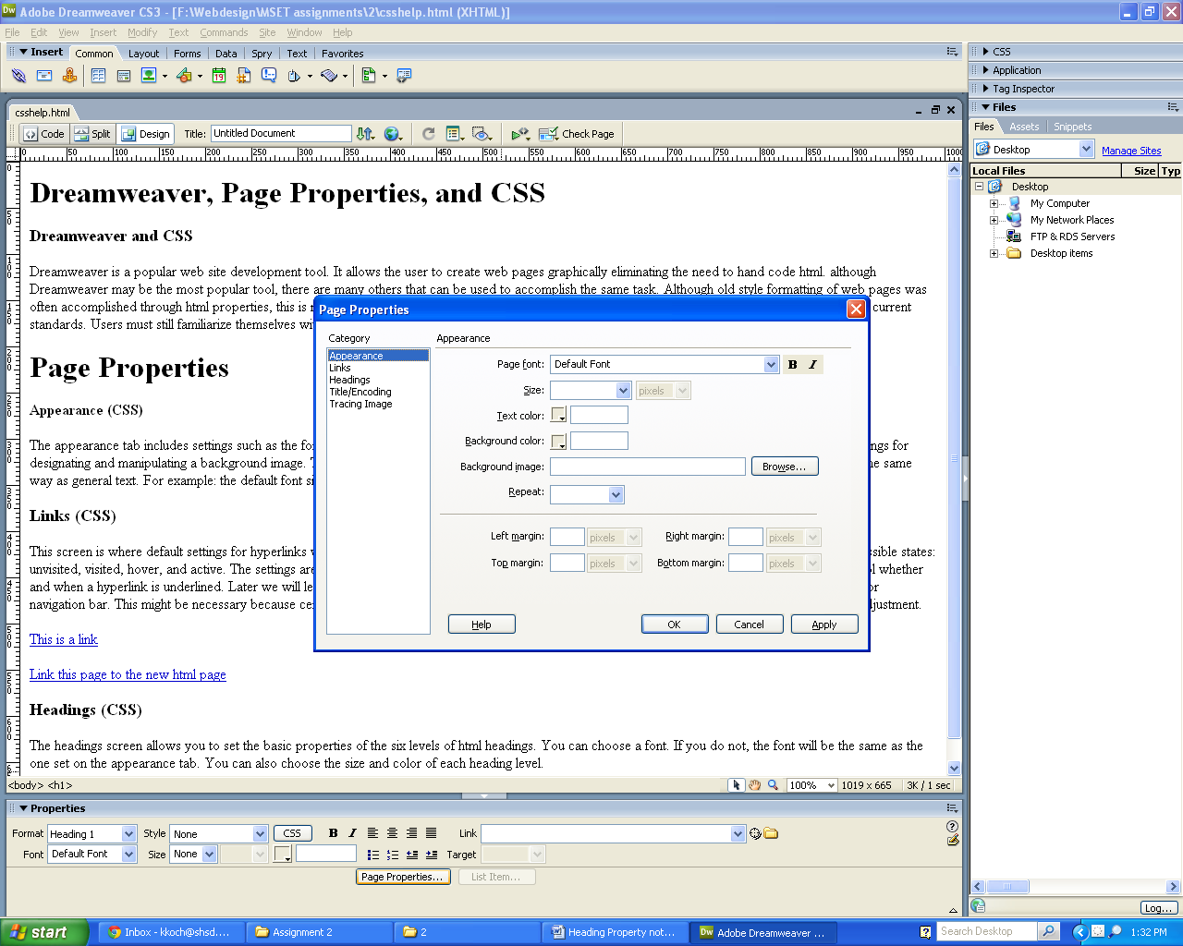Click on the APPEARANCE tab in page properties
   1. We can change *____________________________ ______________________________________*
   2. Let’s insert a picture background
      1. Click on ______________ and locate your image in the *_______________________*
   3. Repeat
      1. Repeat: fills the screen with the image
      2. Repeat X: _________________________
      3. Repeat Y: __________________________
   4. Margins: ________________________________________________
      1. Left
      2. Right
      3. Top
      4. Bottom